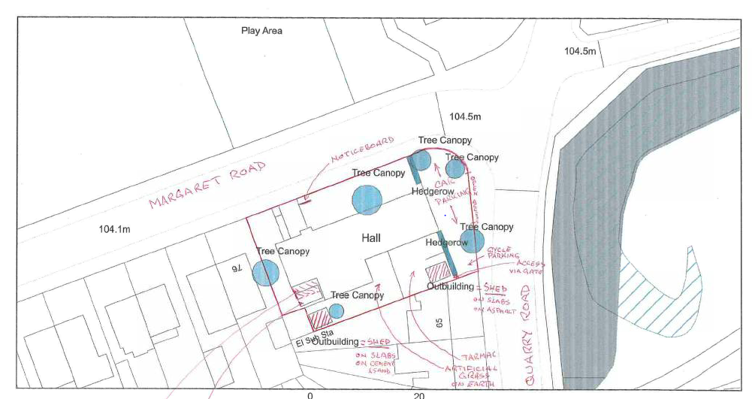

**Appendix 1**

19/01790/FUL – Quarry Village Hall  
Proposed block plan